Cub Scout Roundtable Planning Sheet – 60 minute Format
Topic: Leader Appreciation
Take Away: Those who volunteer their time and resources to help our Packs function are precious. It’s a good thing to take time to thank them. Whether this is done with an award or a presentation at a Pack meeting, or you show your appreciation with kind words or a small gift, the right gesture can mean a lot to others.

Time Allotted | Activity | Assigned To | Content Ideas | Notes for Media Team
10 min | Opening Ceremony | Cub RT Staff or participants | Opening flag ceremony, Pledge of Allegiance, Scout Oath and Law.
40 min | General Session Topic  (All) | Cub RT Staff or participants | With the entire group, discuss ways to show appreciation to the volunteers in the pack  Discuss some ways to show appreciation to den leaders  - Den leader awards  - Flowers given to den leaders at the Blue & Gold Banquet (yellow potted daffodils in a container covered in blue foil)  - Certificates of appreciation given to den leaders  - A thank you card given to the den leader created and signed by all of the Scouts in the den  - A restaurant gift card or other gift card purchased by the parents to give to the den leader  - A den scrapbook with photos given to the den leader  - A hand-written thank you note given to the den leader by the Cubmaster  - Should the recognition for a long-time graduating den leader be different from other den leader recognition?  Discuss some ways to show appreciation to parents and guardians who have helped the den or pack  - For those who have chaired a big event such as the Pinewood Derby or Blue & Gold Banquet, recognize them publically at the event itself. Recognize them again at the pack’s main recognition event of the year. Certificate? Gift card? Other?  - For those who have helped in a smaller way (Scouting for Food driver, event planning committee member, popcorn sale parent), recognize them at the pack meeting immediately following their volunteerism. Ask them to stand and give them applause. Recognize them again at the pack’s main recognition event of the year.  Discuss some ways to show appreciation to the pack’s top leadership  - A pack photo with a card signed by all of the Scouts and parents in the pack  - A gift card  - A certificate of appreciation  - Flowers  - Remember to show appreciation to those who have been in important pack leadership position behind the scenes, for example the Pack Treasurer  - It’s a good idea to recognize the graduating volunteers at the Blue & Gold Banquet. Recognize the other volunteers, many of whom will be continuing in their current roles, at the end of the program year. This could be the pack meeting held in the month of May.  Review BSA knots that are appropriate for the volunteers in your pack and present those as they are earned or at the Blue & Gold Banquet or year-end pack meeting.  How might the pack show appreciation to the chartering organization, if appropriate?  Have the group share some best practices for a recognition ceremony held at a pack meeting.
10 min | Q & A | Cub Scout RTC &  District Committee | Opportunity to answer any additional Leader Recognition Interest Topic Questions
5 min | Closing | Cub Scout RTC | Do the Thank You closing ceremony to recognize your RT attendees. The ceremony is in the resource information below.

Resource Information
Leader Recognition Ceremony
Cubmaster: Tonight, I would like to recognize one of our Den Leaders who has completed the requirements for the Den Leader Award. Will ____________ please come forward? We want you to know that we appreciate all the time and effort that you put forth. You are helping shape these Scouts’ lives and building leaders of tomorrow. I would like to present to you the Den Leader's Award Certificate and Square Knot that you can wear on your uniform.

Scouting is a Candle
Materials –
Candles - longer tapers, OR small birthday cake candles
Mount each candle on a piece of wood/plywood. Write in marker: Thank you for shining your light in our pack”

Cubmaster or Committee Chair: Scouting is a candle that will light you on your way.
It’s trying on your honor, and helping every day.
Exploring worlds around you and looking wider still.
Pitching tents out in the woods and hiking up a hill.
Music and voices blended under God’s majestic sky,
Helping those around you, kindness in great supply.
The meaning in a moment, in a smile, or in a tear,
Makes you a little taller with each new Scouting year.
A promise to your God and to your country, too,
Makes you a part of your world, and your world a part of you.
It’s something that you carry wherever you may go,
A secret deep inside you that only Scouts would know.
But it’s the kind of secret that you want the world to know,
You can’t hide all the happiness; you can’t hide all the glow.
A candle glows together, it shines externally.
Make it shine on everyone, that’s the way the world should be.
Cubmaster: Tonight we would like to say thank you to some leaders and parents who have lit up our pack meeting with their helping hands. (Call adults forward and give them thanks and the memento.)

And Then Some
These three little words are the secret to success.
They are the difference between average people and top people in most organizations.
The top people always do what is expected… and then some.
They are thoughtful of others, they are considerate and kind… and then some.
They meet their obligations and responsibilities fairly and squarely … and then some.
They are good friends and helpful neighbors… and then some.
They can be counted on in an emergency… and then some.
I am thankful for people like this for they make the world more livable.
Their spirit is summed up in these three little words… and then some.

Lighting the Path

Materials –
Candle or a small flashlight mounted on a display;
Write on the display – “thank you for lighting our path”
Words –
There are some leaders and parents with us tonight who have shared the bright light of their enthusiasm with us all year, and we need to thank them for their time and their dedication to
our pack program. They lit our path with the energy they put into this event and I would like them to come forward so we can show them our appreciation. (Call adults forward and present award.)

Leader Recognition:---------------
Training Knots:
Boy Scouts offers a variety of awards for leaders and scouters that can be worn on their uniforms to show their service and commitment.
The training knots are patches that are awarded based on training that a BSA volunteer has completed. These are awarded at the unit level and are a great way for volunteers to show their experience.
The training knots and award knots are each a rectangular patch with a square knot on it. The patch is displayed on the uniform to denote that the wearer has received the corresponding award. The award is usually in the form of a certificate and many awards also include a medallion or other memento.
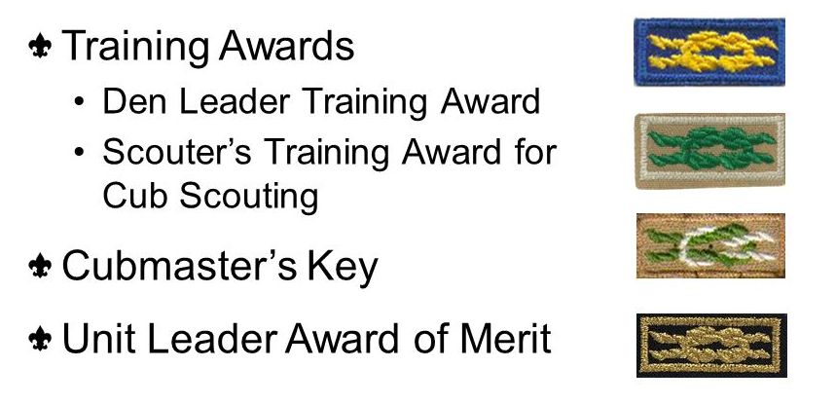
The committee chair or Cubmaster can download the requirements from the BSA site. Once the volunteer has completed the required tasks the Pack can bring the requirements form to a scout shop and purchase the patch for the volunteer.
Service Stars:
The BSA offers an award called a service star. These awards can be awarded by the Pack or troop. The Service Star is a small medal which denotes the length of time the person has been involved in scouting. To clarify this program here are some questions and answers:
What are service stars?
Small pins that indicate how many years of tenure a scout or scouter has in the BSA. Each star is worn on a circular backing whose color indicates which phase of scouting it represents.
What do the colors indicate?
Four colors represent youth service: Gold for Cub Scouting (including Webelos scouts), green for Boy Scouting, brown for Varsity Scouting, and red for Venturing and Sea Scouts. Adult service is shown with a blue backing. Adults may combine their youth and adult tenure and just wear stars with blue backing.
How do the stars show the number of years of service?
Each star displays a number. The youth or adult member combines stars to show his or her years of service. For example, a boy who was a cub scout for four years and a boy scout for six years would wear a four-year service star on a gold backing and a six-year service star on a green backing. An adult with 27 years of service would wear two stars on blue backing: A 20-year service star and a seven-year service star.
What service stars are available?
Stars are available in one-year increments from one to 10. After that, they go in five- or 10-year increments up to 90. Pins and backing may be purchased at local scout shops.
Where are service stars worn?
Service stars are worn above the left pocket of the uniform shirt. If a medal or an embroidered knot is worn, service stars are worn a quarter of an inch above the medal or knot.
Who is eligible to wear service stars?
Any youth or adult member with at least one year of tenure is eligible.
Must a person’s tenure be continuous?
No. Someone who was a Scout as a youth and returned years later as an adult volunteer could wear stars representing both periods of tenure.

Miscellaneous Thank You Recognitions
Sometimes you want to show thanks to a volunteer for just helping out, or they came in the last second and took care of something that fell through the cracks. Well let’s make an award for that, and let’s not break the bank doing it. Here are some examples.
- Take a bottle or can of AW (root beer or cream soda) and add a tag labeled “Your work is AWsome!”
Take a bag of Gummy Bears and ad a label with “You are Beary helpful!”
Take a bag or can of Nuts and label it with “We're nuts about you!”
Get a bag or box of Goldfish Crackers and add a label to it with “You're o-fish-ally the best!”
Take a 100 Grand Candy Bar and add a label with “You're worth 100 Grand!”
Take a Mr. Goodbar and label it with “You always do such a Good job!”
Take a Mounds Candy Bar and label it with “You're mounds of help!”
Take a Skor Candy Bar and label it with “We skored when we got you as a leader!”

These are just a few things you could do but you get the basic idea. So go ahead and tell those people who help your pack what they really mean to you.

Closing Ceremony
Thank you closing
The den brings a banner or poster to the front of the room and holds it up so all can see a “Thank You for Having Faith in Me” poster or banner created earlier. Have the preassigned den say the following:
CUB SCOUT 1: Thank you, parents, for helping us earn our ranks.
CUB SCOUT 2: Thank you, den leaders, for showing us new things.
CUB SCOUT 3: Thank you, Cubmaster, for leading us each month.
CUB SCOUT 4: Thank you, pack committee, for helping us to grow.
CUB SCOUT 5: Thank you, Cub Scouts, for giving us goodwill.

ALL: Thank you and Good Night

Resources for Topic:
Listing of Awards BSA offers Leaders and Adult volunteers http://www.scouting.org/scoutsource/CubScouts/Leaders/Awards/AdultAwards.aspx
A listing of various Scouting Awards on Scoutstuff.org :
http://www.scoutstuff.org/catalogsearch/result/?q=award

